Jenkins Assignment 5
Create three slave and build three jobs, where job-1 will deploy index.html on slave 1 from repository which is in main branch, job-2 job-1 will deploy index.html on slave 2 from repository which is in 2026Q1 branch and job-3 will deploy index.html on slave 3 from repository which is in 2026Q2 branch, job-2

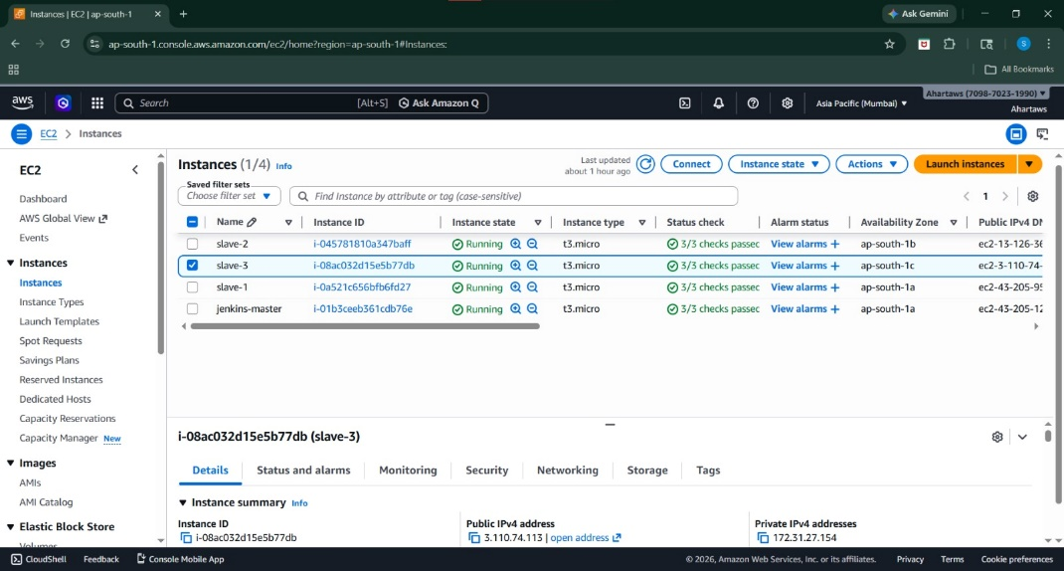
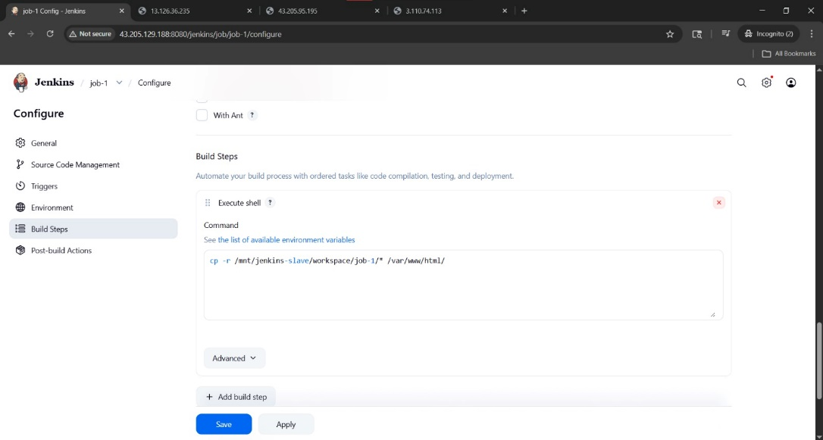
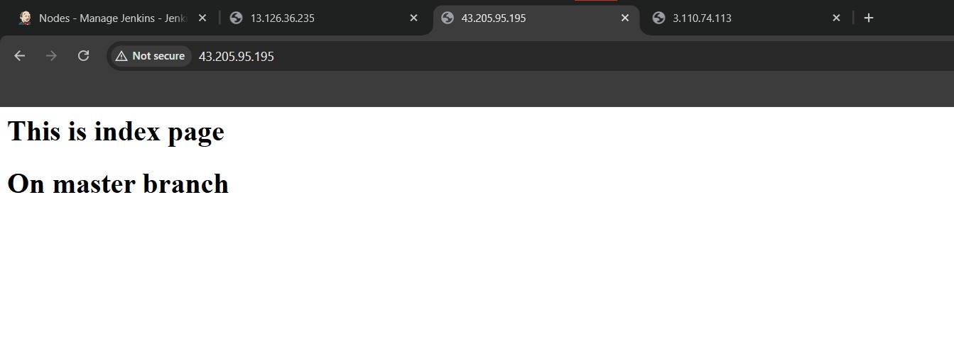

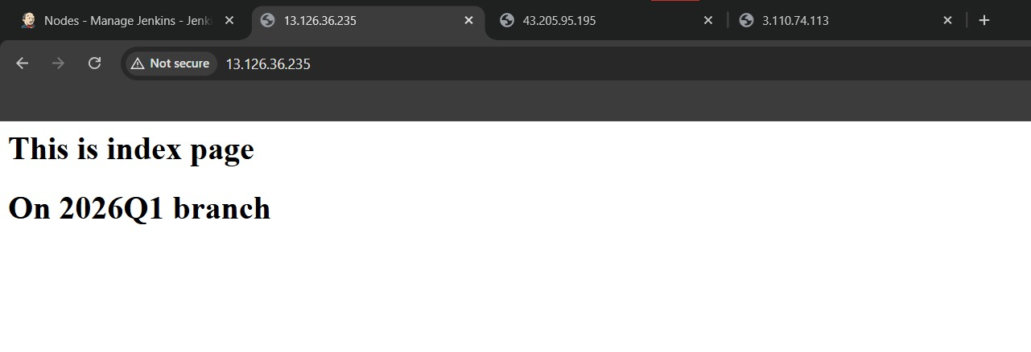
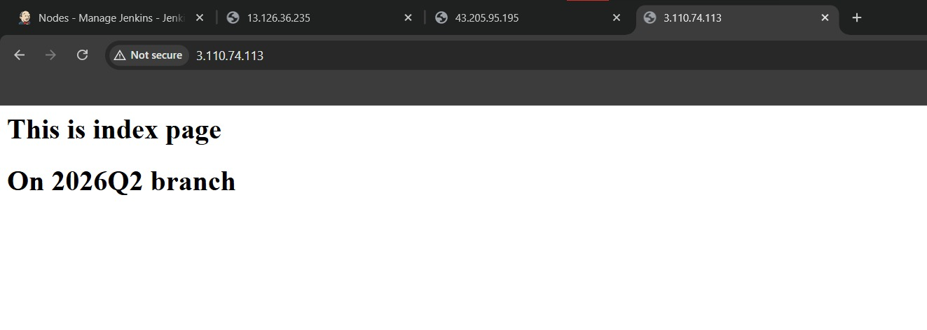

Using pipeline jobs
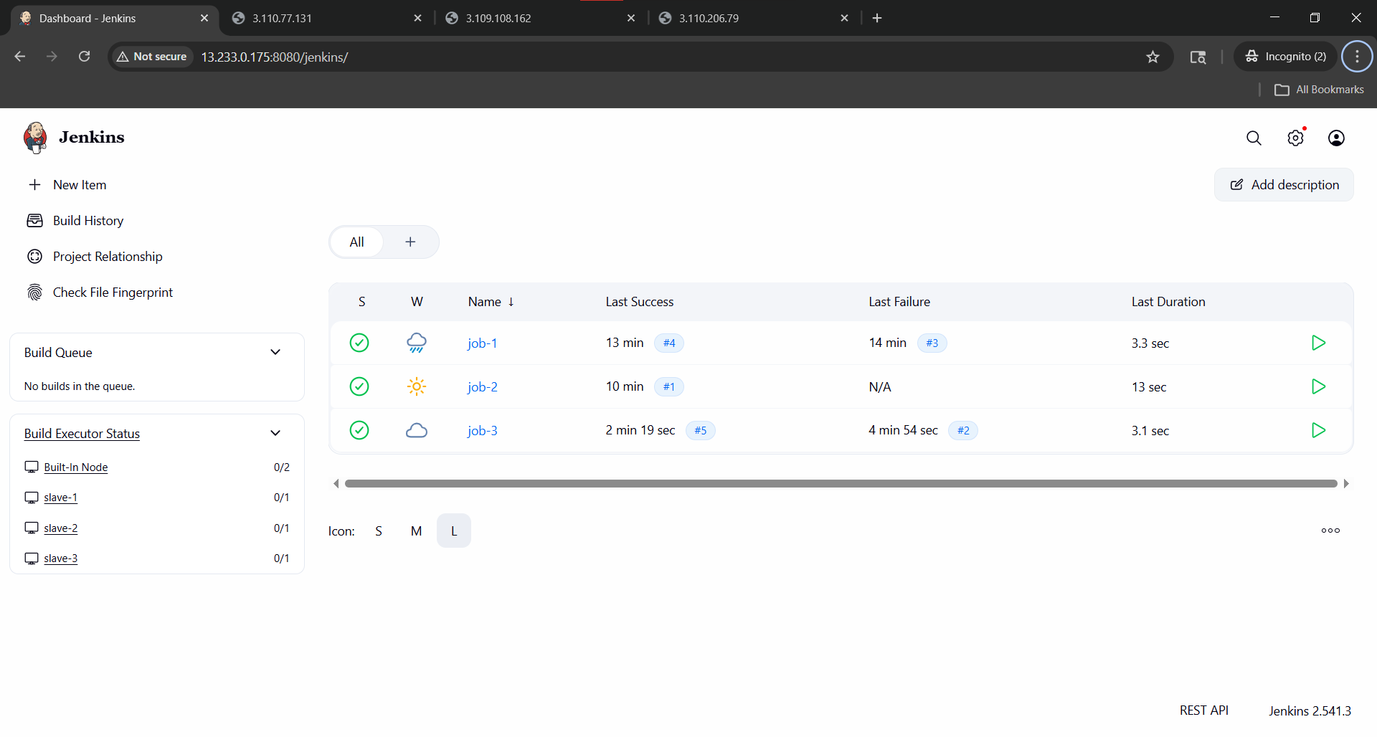

pipeline{
agent{label 's1'}
stages{
stage('install httpd'){
steps{
sh 'sudo yum install httpd -y'
sh 'sudo systemctl start httpd'
sh 'sudo systemctl enable httpd'
}
}
stage('clone repo'){
steps{
git branch: 'main', url: 'https://github.com/sahil-ramteke/jenkins1'
}
}
stage('copy file'){
steps{
sh 'sudo cp index.html /var/www/html/'
}
}
}
}

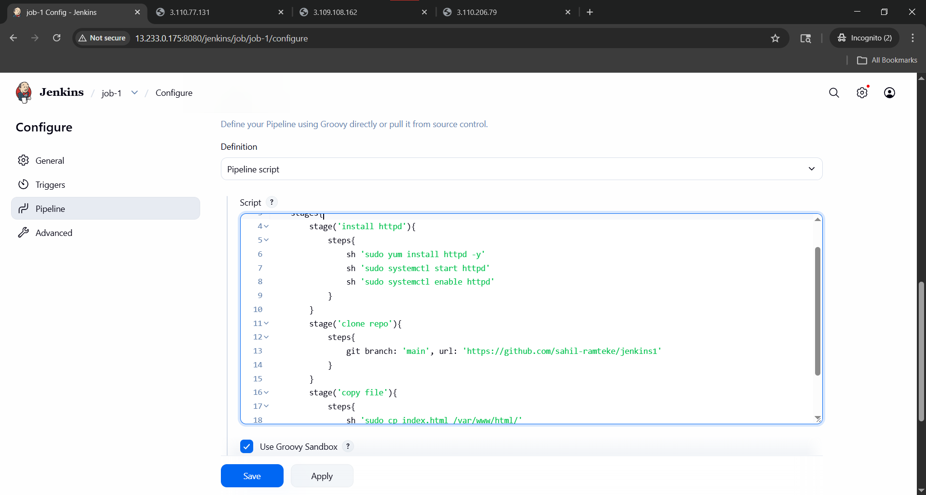

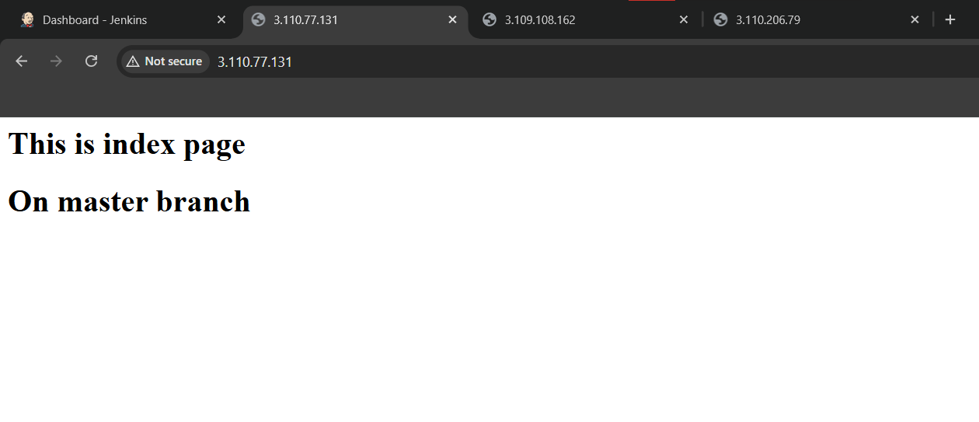
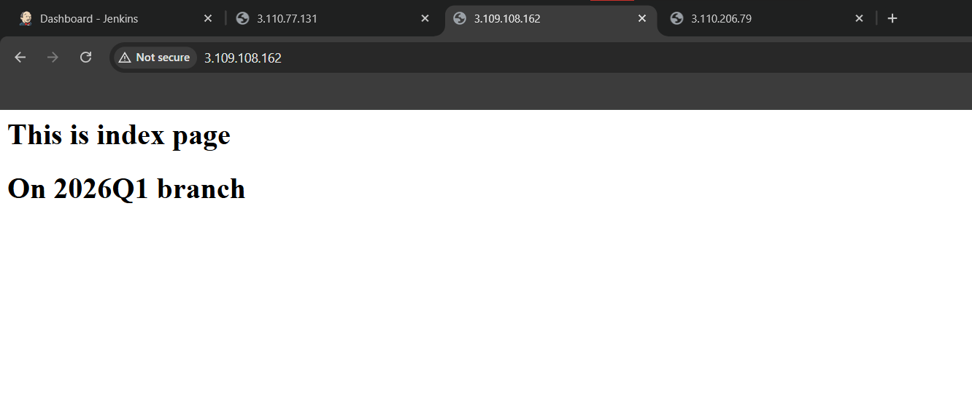
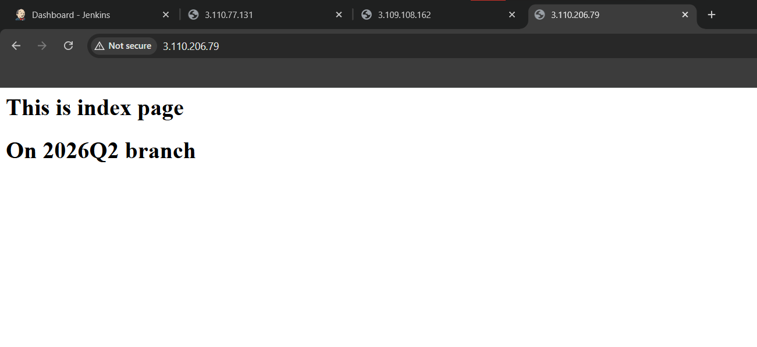

Using Jenkinsfile
